|  |  |
| --- | --- |
| **Team ID :** | LTVIP2025TMID57320 |
| |  |  |  | | --- | --- | --- | | **Project Title** | **:** |  | | |  |  |  | | --- | --- | --- | |  |  | OrderOnTheGo: Your On-Demand Food Ordering Solution | |

**Project Structure**

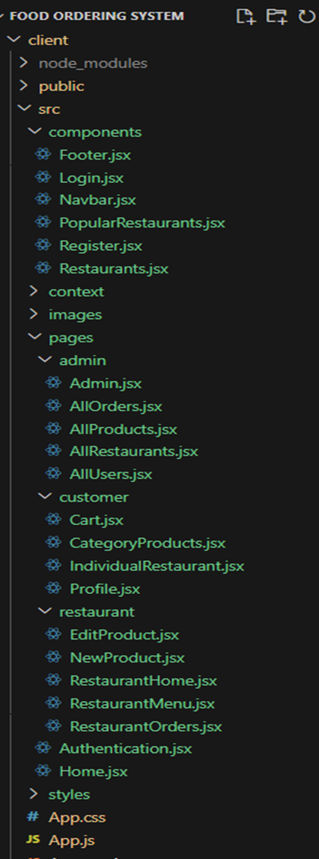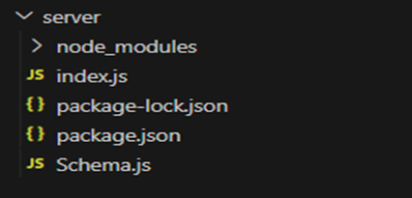

This structure assumes a React app and follows a modular approach. Here's a brief explanation of the main directories and files:

• src/components: Contains components related to the application such as, register, login, home, etc.,

• src/pages has the files for all the pages in the application.